SHIP TYPE |  | Special Service Vessel – Seismic Research
CLASSIFICATION |  | BUREAU VERITAS
BUILDER |  | REMONTOWA SA. Gdansk, Poland, 2012
YEAR CONVERTED |  | 2019
IMO NUMBER |  | 9606699
PORT OF REGISTRY |  | Nassau
FLAG |  | Bahamas
CALL SIGN |  | C6EJ6
OFFICIAL NUMBER |  | 7001264
OWNER: | REM ANDES AS,  6092 FOSNAVAG | MANAGER: | REM MARITIME AS,  6092 FOSNAVAG
MAIN DIMENSIONS |  | CLASS NOTATIONS
Length O. A. | 87,90 m | 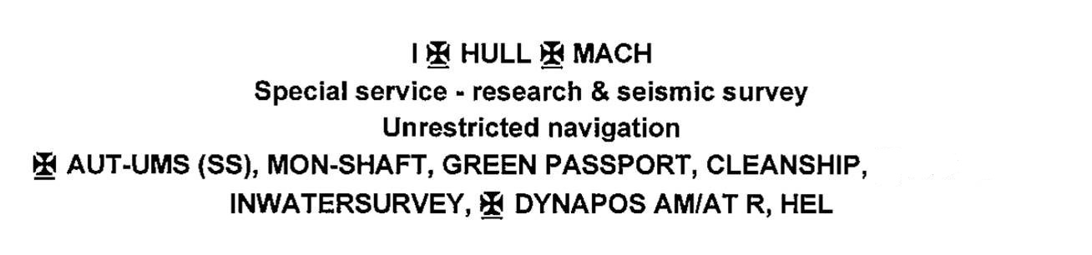
Length P. P. | 81.52 m
Breadth | 18,80 m
Draft | 6,50 m
Gross Tonnage | 5458
Net Tonnage | 1637
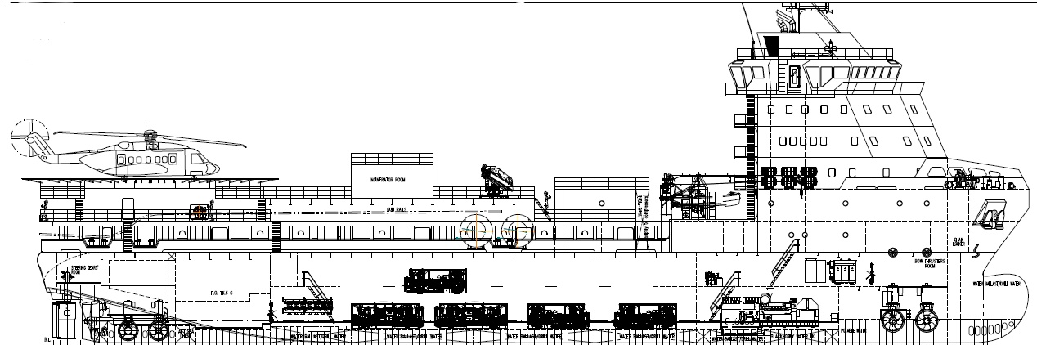

MACHINERY AND PROPELLER PLANTS  Main propulsion system Main Engine 2 x MAC 6M25 rated 1900 kW (2548 BHP) each El Motor PTI 2 x PTI Motors rated 2000 kW (2682 BHP) each Combined Propulsion Hybrid Mode 6500 Kw/8716 BHP Propellers 2 x CPP, Berg, 3m Bow Thruster 2 x 900 kW,12,5 T Thrust, Scana  Stern Thruster 2 x 600 kW, 8.7 T Thrust, Scana  Power Plant Main Generator 2 x CAT 3516C rated 2,350 kW (3,151 BHP) /690V/ 60Hz/ 3Ph Shaft Generator 2 x 2,000 kW (2,435 BHP) /690V/ 60Hz/ 3Ph Emergency Generator 1 x 398 kW (533 BHP)/ 690V/ 60Hz/ 3Ph  DECK MACHINERY  Deck Crane: TTS GPT 80-2-12 Telescope Hydraulic Crane SWL 2T  Deck Crane MELCAL FL35T5 Offshore Crane, SWL:4T/4,6m-1.3T/14m  Anchor Windlass 2 x 11 T, Electric driven, Brattvaag  Anchor Chain 2 x 275 m x 54 mm (Ø)  Anchor (Bow) 2 x 2,840 kg, High Holding Power Anchors  Capstan 2 x 10 T @ 35.2m/min, Brattvaag  Workboat 1 x Jiangyin Neptune Marine FRP  Static Bollard Pull 101.90 MT  NAVIGATION EQUIPMENT  Auto Pilot: SPERRY MARINE “NAVPILOT 4000”  DGPS: FURUNO GP-150  Radar s: FURUNO FAR-2X17B FURUNO FAR-2X37S-BB  Gyro Compass 3 x Sperry Marine NAVIGAT X MK1  Magnetic Compass SPERRY MARINE  ECDIS FURUNO “TECDIS”  DP system KONGSBERG K-POS DP21  Navigation Echo Sounder: FURUNO FE-720  GMDSS FURUNO A1, A2, A3  VDR FURUNO VR-3000  AIS FURUNO FA-150  Speed Log FURUNO DS-60  Facsimile FURUNO FAX-408  SEISMIC EQUIPMENT  Energy Source 2 x LMF48/138-207 48 m3/min (1699 cfm)  3 x LMF31/138-207 31 m3/min (1099 cfm  Source Controller Bigshot  Source Elements Sercel G-Gun II  Sub Arrays up to 10  Volume up to 8000 cu.in.  Operating Pressure 138 bar / 2000 psi  On-line Navigation System: Project specific  Primary Navigation: Project specific  GPS receiver: Project specific  Secondary navigation: Project specific  GPS receiver: Project specific  Gun array tracking: RGPS Kongsberg Seatrack 330  Acoustic: Project specific USBL  QC QUALITY CONTROL  Navigation QC Teledyne Smart Source D  QC Seismic Processing Open CPS | SPEED AND FUEL CONSUMPTION  Cruising Speed: 10,0 knots / 16.0 m3  Max speed: 14,0 knots / 21.0 m3  DP operations: var. / 12.0 m3  CAPACITIES  Fuel: 2980 M3 at 98%  Fresh water: 664 M3  Sewage: 23.8 M3  Oil Residue: 20,8 M3  Fresh water generator: ENWA Reverse Osmosis: 25 m3  Sewage treatment plant: 75 persons x RWO WWT LC 06, 10.8 m3/hr  Incinerator: Atlas 400 SL WS 180.000 kcal/h; max70 kg/h  LIFE SAVING EQUIPMENT  Life Rafts: 12 x 16, Viking  Rescue Boat: 1 x 15 persons, Jiangyin Neptune Marine FRP BA-sets 4 x SCOTT  Air Compressor: 1 x MCH-13/ET  Line Thrower: 4 x Pains/Wessex  Survival Suits: 64 x VIKING  Life Vests: 70  Life buoys: 12  Gas Monitor: 3 x portable sets-Drager  Medical Emergency: 1x Heart-Start AED, Resuscitator  Galley System: 1x CO2 HP System  Emergency Fire Pump: 1x 45 m3/h  Fire Extinguisher: 104/ CO2, Powder/Foam  CO2 System: 1x Fixed ER  1x Fixed Galley  1x Fixed EDG  COMMUNICATION  Inmarsat Fleet broadband: FELCOM 250  VSAT equipment: MARLINK  Inmarsat C: FURUNO Felcom 15  Emergency Radios: 3x VHF ENTEL HT649  M/F and H/F: FURUNO FS-1570  VHF stationary: FURUNO FM-8800S  Internal communication: 1 Automatic Telephone System “VINGTOR”  1 Battery less Telephone System “VINGTOR”  1 Public Address System  Navtex: NX-700  Vessel E-mail: captain@andes.remoffshore.no  ACCOMMODATION  Accommodation capacity: 60 persons  1M Cabins 20 x 1M Cabins with Bathrooms  2M Cabins 20 x 2M Cabines with Bathrooms  Mess: 42 person  Day room: 1 x comfortable outfitted on Deck B  Gym Area. Fully equipped  HELIDECK  D value 19.5 m  “t” value 9.3 t  Location Stern

